**INSOL India presents SIG24 WEBSERIES**on

“**THE “NEW NORMAL FOR INSOLVENCY RESOLUTION”:BEING PREPARED** **& MOVING FORWARD WITH RESCUES**

How Should Insolvency Professionals Tackle The New Normal

Saturday, 6th June 2020  
10:30 – 12:00pm

WELCOME ADDRESS

A.S.Chandhiok  
President, INSOL India

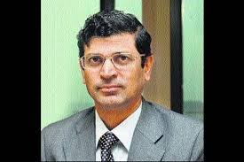

INAUGRAL ADDRESS

Dr. M. S. Sahoo, Chairperson, IBBI

INSOL India will be running its first ever Webinar series on the 6th of June at 10:30am. As India gradually reopens, post COVID 19 India looks very different from the pre- COVID 19. We have to accept this new reality. The total time allocated to this Webinar is 1 hour and 15 minutes, which will include time for Q&A. We will all have questions – what does this mean for insolvency practitioners, how will banks recover/lend/restructure, where will the ‘new money’ come from, how will courts function in time of social distancing, what regulatory changes does India need, amongst others.   
  
INSOL India must stand tall and guide the insolvency industry and the policy changes that this Black Swan event will bring about. This series of web-based events is designed with an intent of doing precisely that with the benefit of INSOL India’s incumbent SIG 24 and other industry experts.

There is no participation fee on this initial webinar, however future series will be subject to a minimal fee.

Delegates will need a computer and internet connection to join the webinar. The platform is entirely browser based – no downloads will be required to enter the webinar.

Delegates will also be able to dial in for audio-only participation.

If you would like to register please contact [contact@insolindia.com](mailto:contact@insolindia.com) and Aditi Khanna [aditikhanna@insolindia.com](mailto:aditikhanna@insolindia.com)

**EMINENT SPEAKERS**



Dr M S Sahoo,   
Chairperson,   
Indian Bankruptcy Board of India

 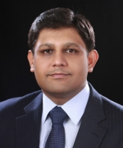   
Bahram N Vakil Dinkar Venkatasubramanian   
Senior Partner Partner, EY   
AZB & Partners Executive member, INSOL India

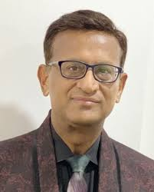 

Anil Goel Pooja Mahajan

Partner, AAA Insolvency LLP Partner, Chandhiok & Mahajan

|  |
| --- |
|  |
| PROGRAMME FLOW - DAY 7th June 2020 |
|  |
| 4:00pm – 4:10pm  4:10pm – 5:10pm  5:10pm – 5:30pm | WELCOME AND INTRODUCTIONS By MODERATOR  *How Should Insolvency Professionals Tackle The New Normal*  Q&A |